# KENDRIYA VIDYALAYA No.2, BOLANGIR

SUMMATIVE ASSESSMENT- II SESSION: 2013-14

CLASS: III SEC___ TIME: 2 ½ Hrs SUBJECT: MATHS MAX.M: 60

NAME: ________________________________________________ Roll No.:______

DATE: ____-03-2014

Invigilator’s Sign______ Examiner’s Sign. _________

|  |  |  |  |  |  |
| --- | --- | --- | --- | --- | --- |
| COMPETENCIES | KNOWLEDGE | UNDERSTANDING | ABILTY IN  COMPUTING | PROBLEM  SOLVING  ABILITY | OVER  ALL  GRADE |
|  |  |  |  |  |  |

KNOWLEDGE

Q1) 1 Kilo Gram=___________________ grams.

Q2) Which of these you need a bigger bag, encircle it.

1 kg popcorns or 1 kg sugar Q3) Which is heavier ? A pumpkin or a potato Q4) 1 Litre=______________mililitres.

Q5) 1 Rupee=___________paise.

Q6) Guess the weight and match.

Elephant Cow Mango Briefcase

less than ½ kg 10 kg more than1000 kg 400kg Q7) Guess the unit you will use to measure the following things.( Litre, ml)

1. Cough Syrup ______________
2. Big bottle of pepsi _________
3. Nail polish____________
4. Water filled tank _________

Q8) Decode the secret message written below.

1. 1B2E3S4T 5O6F7 8L9U10C11K12

_____________________________________________________________

1. 3H3A3P3P3Y3 3N3E3W3 3Y3E3A3R3 323031343 ?

_____________________________________________________________

(1)

Q9) Encircle the side which is heavier.

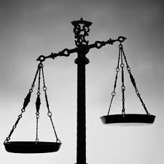 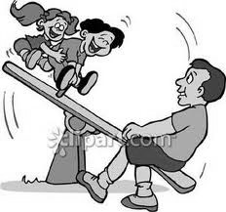

Q10) Read the instruction on how to make 1 cup tea. There are some right/wrong choices. Tick the correct choices.

|  |  |  |
| --- | --- | --- |
| |  | | --- | | Take 1 Bucket / half cup of water. Boil the water. Add 1 spoon/1 kg of tea powder.  Add half cup / half litre of milk. Put 100g/ pinch of elaichi powder. | |  |

UNDERSTANDING

Q11) Continue the pattern.

__________ ____________

Q12) Write in numbers using correct sign.

Three times eight = ________________

Q13) Which of these is the new symbol for rupee?

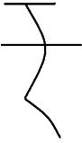

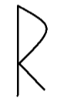

Q14) Rs10 + Rs10 + Rs 10 = Rs__________

Q15) Raju drinks 2 litre of water during summer days. He drinks 800ml during winter. In which season he drinks more?

Ans. ___________________________________________________________________

Q16) Convert

1. Rs 5.00 = ________________Paise
2. Rs 6.50= _________________ Paise

Q17) Arrange the following name in alphabetical order

JOY , AMAN, DIYA, RAJU

Ans. ___________________________________________________________________

Q18) Colour the even number square in the following boxes.

|  |  |  |  |
| --- | --- | --- | --- |
| 4 | 7 | 10 | 5 |
| 21 | 14 | 17 | 26 |

Q19) See the table and answer the question

|  |  |
| --- | --- |
| Favorite Ice cream | Number of children |
| Strawberry | 15 |
| Chocolate | 20 |
| Vanilla | 05 |
| Butter scotch | 08 |

1. The most favorite ice cream ________________
2. The least favorite ice cream ________________
3. Butter scotch is liked more than ________________
4. Total number of children ________________

ABILITY IN COMPUTATION

Q20) Fill in the blanks

1. 18 ÷ 2=___, or ______ X 2= 18
2. 7 X ___ = 56 or 56÷ ___ = 7

Q21) Sum of two odd number is always an ___________ number. (odd/even) Q22) Fill the multiplication grid.

|  |  |  |
| --- | --- | --- |
| X | 80 | 5 |
| 7 |  |  |

Q23) Write the amount of money.



a)

b)

Ans.

__________________

Ans.

___________________

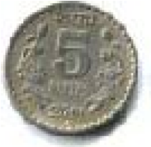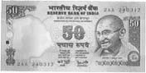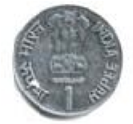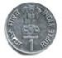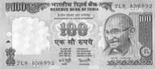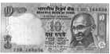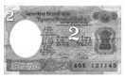

Q24) Write multiplication factors for the following

18

1

X

18

_

__

_

X

_

__

_

_

__

_ X_

__

_

Q25) Fill the cash memo.

|  |  |  |  |
| --- | --- | --- | --- |
|  |  |  |  |
| Item | Rate per item | Rs. | Paise |
| 1 ball  4 pencils  2 toffees | 7.00  2.00  2.00 |  |  |
|  | Total |  |  |

PROBLEM SOLVING ABILITY

Q26) Guess

If cost of one chocolate is Rs 5,then cost of 4 chocolates is _______.

If cost of 1 kg Sugar Rs 30,then cost of 5 Kg sugar is__________.

Q27) How many flowers are there in each group?

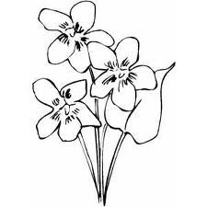 

Ans __________________________________________________________

Q28) Rs 25 added to Rs 50 =______________

Q29) The cost of one copy is Rs.5.What is the cost of seven copies.

Ans. __________________________________________________________

Q30) 24 pen are packed equally in 4 packets .How many pens are in each packet.

Ans. ___________________________________________________________

Q31) There are 12 desks in a classroom. Each desk has 4 legs. What is the total number of legs of the desks?

Ans. ___________________________________________________________

Q32) Shovan has 36 minutes to make rotis. One roti takes 3minutes. How many rotis can be make in this time?

Ans. ___________________________________________________________

___________________________________________________________

Q33) Observe the chart of train journey and answer the question given below.

|  |  |  |
| --- | --- | --- |
| DISTANCE FROM  BALANGIR (in Km.) | STATION | FARE (in Rs.) |
| 80 | Baragarh | 30 |
| 130 | Sambalpur | 52 |
| 280 | Cuttack | 98 |
| 320 | Bhubaneswar | 110 |

Find the distance :

i) From BOLANGIR to CUTTACK: ___________ ii) From BARAGARH to SAMBALPUR: ___________

Find the cost of ticket :

iii) Two tickets from BALANGIR to BARAGARH: ___________ iv) From BALANGIR to CUTTACK: ___________

_________________ SPACE FOR ROUGH WORK _____________

(5)

# KENDRIYA VIDYALAYA No.2, BOLANGIR

SUMMATIVE ASSESSMENT- II SESSION: 2013-14

CLASS: IV SEC___ TIME: 2 ½ Hrs SUBJECT: MATHS MAX.M: 60

NAME: ________________________________________________ Roll No.:______

DATE: ____-03-2014

Invigilator’s Sign______ Examiner’s Sign. _________

|  |  |  |  |  |  |
| --- | --- | --- | --- | --- | --- |
| COMPETENCIES | KNOWLEDGE | UNDERSTANDING | ABILTY IN  COMPUTING | PROBLEM  SOLVING  ABILITY | OVER  ALL  GRADE |
|  |  |  |  |  |  |

|  |  |
| --- | --- |
| Q1) | Metres = _______________ cm (250,25,50,100) |
| Q2) | of 1 kg = ______________ gram(75,750,500,300) |
| Q3) | 21 days = ______________ weeks. |
| Q4) | _______________ is the longest chord of a circle (Radius, Diameter, Perimeter) |
| Q5) | 1 litre = ___________ millilitre (10,100,1000,500) |
| Q6) | Draw circles of 3cm radius with centre on same line. |
| Q7) | Name two things: |

KNOWLEDGE

|  |  |
| --- | --- |
| that you usually buy in grams | that you usually buy in Kilograms |
| i) | i) |
| ii) | ii) |

(6)

Q8) Frame a question for given statement.

150 sweets and 30 children.

_______________________________________________________________?

Q9) Complete the tiling pattern and colour it.

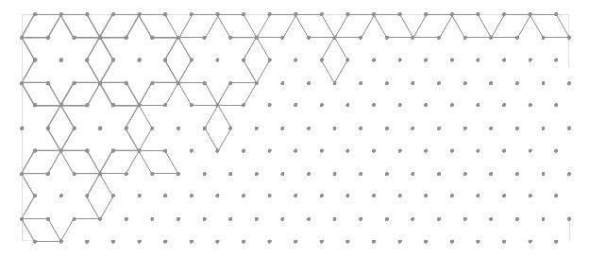

Q10) Arrange 12 flowers in 2 different combination in such a way that each row have same number flower.

UNDERSTANDING

Complete the patterns( for Q.11 &Q.12)

Q11) 26Z, 25Y, 24X, ______, ______, ______

Q12) 9, 109, 209, _____, ______, ______

Q13) Half of half of 40= ______________ (10,20,30,40)

Q14) One fourth is also called as _____________(Half, Quarter, full)

Q15) If radius is 3cm then diameter = __________ cm.

Q16) Razia wants changes for Rs.500 .How many notes will she get

All 100 notes ____________ All 50 notes ____________

Q17) Make 9 kg using weigh of 5kg, 6kg and 2kg only.

________________________________________________________________

Q18) Draw four different way to cut a rectangle into four equal parts.

Q19) Observe the following drama chart and the answer given questions.

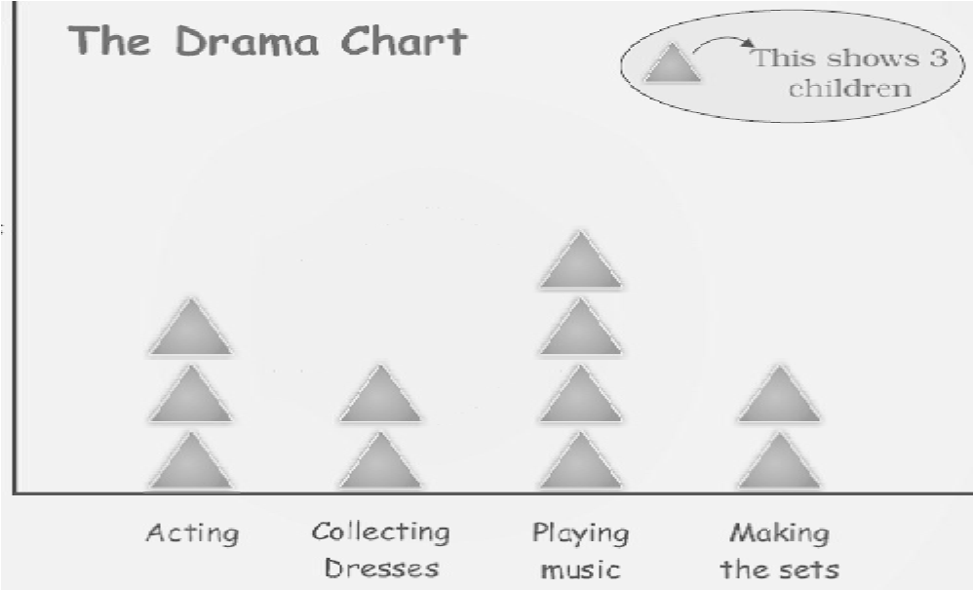

1. How many students are acting in the drama ? __________
2. Which are more – students making the sets or those acting? __________
3. What is being done by most of the children ? __________
4. How many students are collecting dresses? __________

ABILITY IN COMPUTING

Q20) A pen cost 5 rupees, 9 pens will cost __________ rupees.

Q21) 7x8=_______, __________÷8 = 7

Q22) 8 legs means 2 cats,12 legs means______ cats.

Q23) Complete the number tower.

1

2

3

4

5

Q24) Fill in the blank with ‘+’ ‘_’ X ‘ ÷’ to make the statement true.

7 3 = 21 3 = 7 3 = 10 3 =7

Q25) Distribute 72 apples equally to 3 group, each group will get how many apple ?

_________________________________________________________________

Q26) Using number 1 to 6, complete the magic triangle in such a way that each side adds upto 9.

Q27) Look at the postal rates given in the chart and answer the given questions.

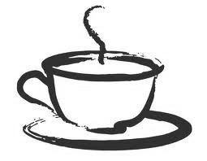

1. Cost of 2 Inland letters=__________
2. Cost of four post cards=_________
3. How much will you have to pay for stamps on a letter weighing 50 grams ?_____
4. Find the cost of sending a parcel of 220 grams?_______

PROBLEM SOLVING ABILITY

Q28) Find the perimeter of the given figure. 10cm

Ans. _____

5cm 5cm

8cm

Q29) Colour portion

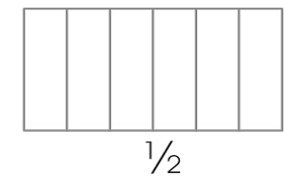

Q30) Write a secret message in numbers (i.e. A=1,B=2).

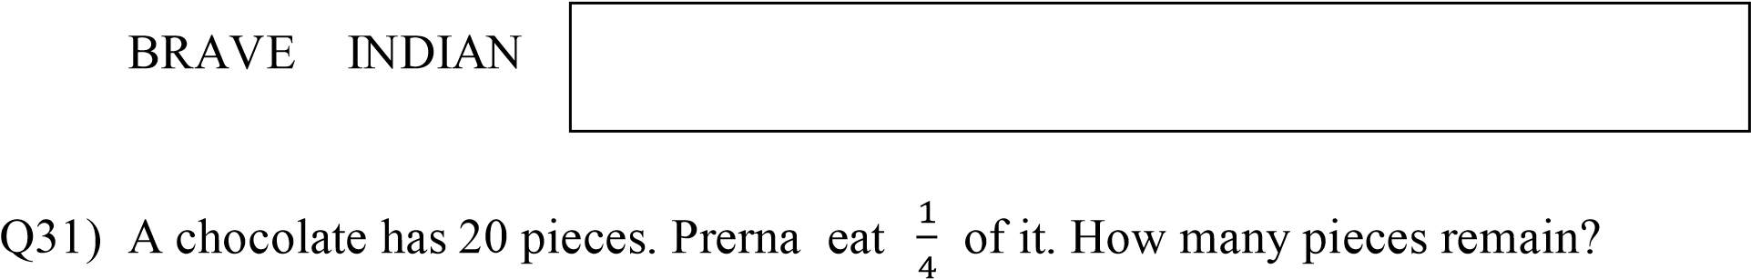

Ans. ________________________________________________________________

________________________________________________________________

Q32) Simran has made a necklace of 18 sea-shells. How many such necklaces can be made using 90 sea-shells?

Ans. ________________________________________________________________

________________________________________________________________

Q33) A hockey field is 91 m40 cms long and 55 m width. How long is the boundary of the field ?

91m 40cm

Ans.

55m 55m 55m

91m 40cm

Q34) Make a chapatti chart for the given data.

|  |  |
| --- | --- |
| Colour they like | Number of students |
| Red | 20 |
| Green | 10 |
| Blue | 10 |

Q35) Look at the pricelist chart and solve the question given below.

|  |  |  |
| --- | --- | --- |
| Sl no. | Items | Price per  Kg in Rs. |
| 1 | Apple | 80 |
| 2 | Orange | 40 |
| 3 | Grapes | 60 |
| 4 | Mango | 20 |

Find the price of PRICE CHART a) Kg Apple =

1. 5 kg Orange =

1. kg Grape=

1. kg mango+ kg Orange =

___________________ ~* SPACE FOR ROUGH WORKS *~________________

# KENDRIYA VIDYALAYA No.2, BOLANGIR

SUMMATIVE ASSESSMENT- II SESSION: 2013-14

CLASS: V SEC___ TIME: 2 ½ Hrs SUBJECT: MATHS MAX.M: 60

NAME: ________________________________________________ Roll No.:______

DATE: ____-03-2014

Invigilator’s Sign______ Examiner’s Sign. _________

|  |  |  |  |  |  |
| --- | --- | --- | --- | --- | --- |
| COMPETENCIES | KNOWLEDGE | UNDERSTANDING | ABILTY IN  COMPUTING | PROBLEM  SOLVING  ABILITY | OVER  ALL  GRADE |
|  |  |  |  |  |  |

KNOWLEDGE

Q1. Choose the correct answer:

1. Length of the boundary is called____________
   1. Area ii) Perimetre iii) Volume iv) Square
2. Volume of a cuboid =length x breadth x _________________
   1. Width ii) Area iii) Perimetre iv) Height
3. 25 paise = __________ rupees.
   1. 2.5 ii) 0.25 iii) 0.025 iv) 25.0
4. 99cm = _______ metre
   1. 0.99 ii) 9.9 iii) 0.9 iv) 0.09
5. 7 tenth is same as = ______
   1. 7.0 ii) 7.10 iii) 0.07 iv)0.7

Q2. Give the answer:

1. Match each shape below with a box into which it will fold.

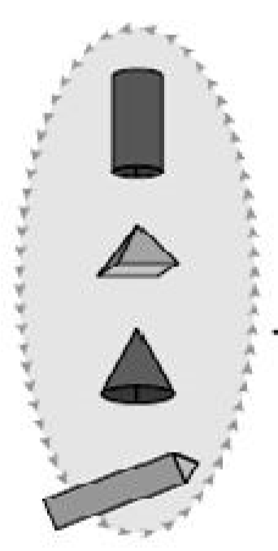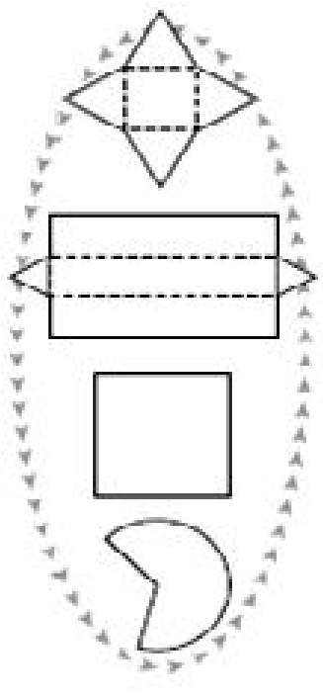

1. Study the following Tally marks and fill in the blanks:

|  |  |  |
| --- | --- | --- |
| Vehicle | Tally mark | Number |
| Car |  | ………….. |
| Bus |  | …………. |
| Truck |  | ……….. |
| Cycle |  | …………. |
|  | TOTAL | …………… |

1. Find the Area and the Perimeter of the given square

Ans:

8cm

1. Find the volume of the given Cuboid :

4 cm

Ans:

2 cm 5 cm

1. The favourite fruit of the students in a class is given in the Pie Chart .

Banana apple

5

15

25

5

5

10

mango

grapes pine apple

How many students are there in the class ? ________________

One- fourth of the total children like to eat________________.

UNDERSTANDING

Q3. Write in number – One point zero two five: ___________

Q4. 10 – 2.5 = _________

i) 9.5 ii) 8.5 iii) 7.5 iv) 6.5

Q5. 123 = ____________

100

i) 123 ii) 12.3 iii) 0.123 iv) 1.23

|  |  |  |  |  |  |  |  |
| --- | --- | --- | --- | --- | --- | --- | --- |
| Q6. | | If the map Scale is 1cm = 100 km , then 3cm = _______ | | | | |  |
|  | | i) 100 km ii) 200 km iii) 300 km | | | | | iv) 400 km |
| Q7. | | Shade 0.3 part of the given figure | | | | |  |
|  | |  | |  |  |  |
|  | |  | |  |  |  |

Q8. Write the missing numbers:

12 x 23 = _____ + _____ + _____+ ____

= _______________

|  |  |  |
| --- | --- | --- |
| X | 10 | 2 |
| 20 |  |  |
| 3 |  |  |

Q9. The temperature of a city is given below. Find out the difference between the highest and the lowest temperature ?

42 oC

40

Ans:

32

o

C

30

23

o

C

20

10

0

Q10. An egg costs three and half rupees. How much will one dozen egg cost?

Ans:

Q11. The list of food each person needs for one day is given

|  |  |  |
| --- | --- | --- |
| Food | For one day |  |
| Rice | 100 g |  |
| Flour | 100g |  |
| Pulses | 60g |  |
| Oil | 50g |  |
| Sugar | 50g |  |
| Salt | 5g |  |
| Dalia | 40g |  |

1. What is the total weight of food for one day in each person’s bag?

Ans: __________________________________________________________

1. What is the total weight of food for six days in each person’s bag?

Ans: __________________________________________________________

1. For six days each person will need

i) Rice and Flour= __________g ii) Dalia = ______________g

ABILITY TO COMPUTE

Q12. Choose the correct answer:

a) If the volume of a marble is 2ml , then the volume of 5 marbles is ______

|  |  |  |  |
| --- | --- | --- | --- |
| i) ml  b) 170÷5 = ____________ | ii) 10 ml | iii) 20 ml | iv) 8ml |
| i) 34  c) 3200 x 40 = _____________ | ii) 43 | iii) 5 | iv) 24 |
| i) 12800 | ii) 128000 | iii) 324000 | iv) 9200 |

Q13. (a) A two rupee coin weighs 6 gram. What will be the weight of a bag having 2400 such coins?

Ans: __________________________________________________________

__________________________________________________________

(b) There are 25 laddoos in 1 kg . how many laddoos will be there in 15 kg?

Ans: __________________________________________________________

__________________________________________________________

__________________________________________________________

1. 32 x 45 = _________
2. 984 ÷ 12 = ____________

Q14. Look at the Daily Wages rate chart and answer the following questions:

|  |  |
| --- | --- |
| State | Wages for one day |
| Haryana | Rs 240 |
| Rajasthan | Rs 85 |
| Madhya Pradesh | Rs 110 |
| Odisha | Rs 95 |

1. Which state has fixed the highest amount? _____________________

1. Which state has fixed the lowest amount? ________________________

1. Sadhu is a worker in Odisha . if he works for 2 weeks , how much will he earn?

Ans: _________________________________________________________

_________________________________________________________

_________________________________________________________

1. How much will a worker in Madhya Pradesh get in one month?

Ans: _________________________________________________________

_________________________________________________________

PROBLEM SOLVING ABILITY

Q15. The volume of 16 one rupee coins is 10ml. what is the volume of 32 one rupee coins? _________

i) 15ml ii) 30 ml iii) 10ml iv) 20ml

Q16. The Area of a Square having side 1cm is= __________________

i) 4 sq cm ii) 1 sqcm iii) 2 sqcm iv) 3 sqcm

Q17. The volume of a cube having side 3 cm is ______ cu cm.

i) 3 ii) 6 iii) 9 iv) 27

Q18. A Five rupee coin weighs 9gm . How many five rupee coins are there in a bag which weighs 36kg?

Ans: _________________________________________________________

_________________________________________________________

Q19. A milk seller sells 13 litre of milk every day at Rs 25 per litre . How much does he earn in a day?

Ans: _________________________________________________________

Q20. The fencing of a square garden is 60m in length. How long is one side of this garden?

Ans: _________________________________________________________

Q21. 810 people are watching a movie in a hall. If the hall has 45 rows, how many people can seat in each row?

Ans: _________________________________________________________

_________________________________________________________

_________________________________________________________

Q22. A thin wire of 20 cm long is formed into a rectangle. If the length of this rectangle is 6 cm, What is its breadth? What is its Area?

Ans: _________________________________________________________

_________________________________________________________

_________________________________________________________

_________________________________________________________

_________________________________________________________